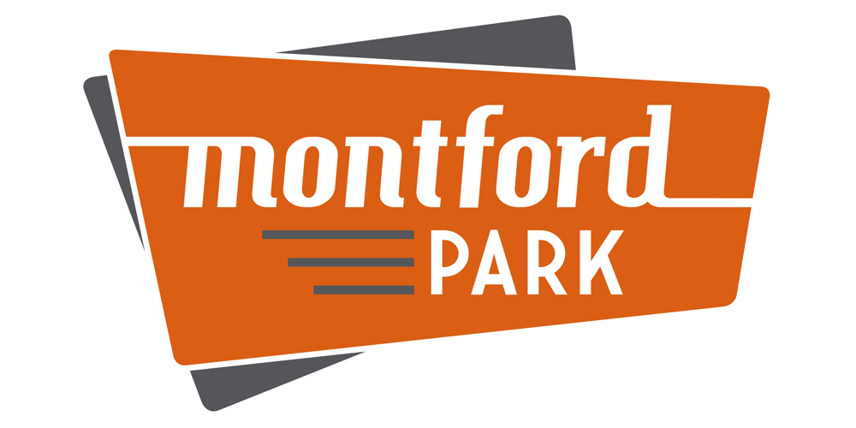
Montford Park Partners
  - Q1 2022 Newsletter

What do we do?
Updates:
Block Party
Fall 2022
Date: October 1st
Facilitated by:
3rd Rock Events!

Quarterly Community Meetings Montford Park residents and business owners. We want your feedback on how we can continue to add value to the neighborhood, and we would love to see you!

3/24/22 – 10 Park Lanes
5 PM - 6:30 PM

6/23/22 - TBD - 5 PM - 6:30 PM
9/22/22 – TBD - 5 PM - 6:30 PM
12/15/22 – TBD - 5 PM - 6:30 PM

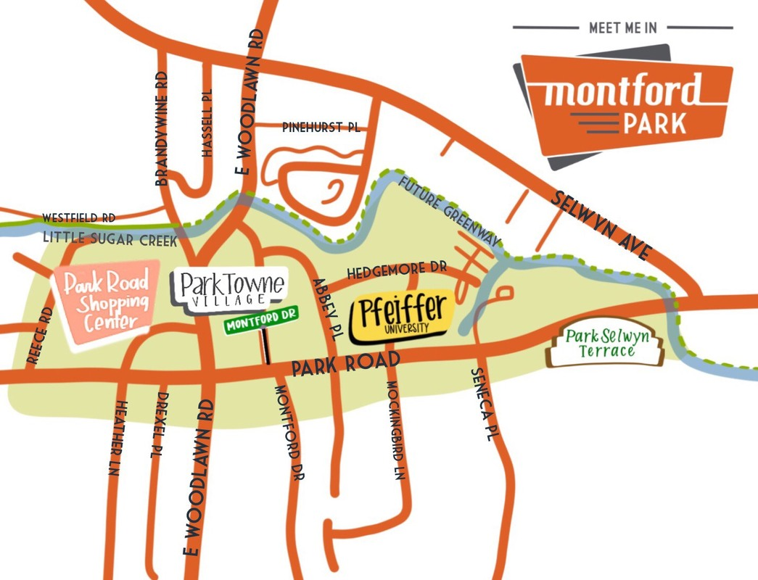
Montford Park Partners is a 501(c)6 nonprofit entity formed in 2016 with the mission to enhance the livability, viability, and visibility of the neighborhood. ​In support of our mission: The Board helps businesses expand their presence in-person and/or online, host community events for residents/businesses, and partner with City of Charlotte officials to improve the neighborhood for all to enjoy.

Meet the Board 2022-2023

Caitlin Owens John Vieregg Paul Dubler Marshall Beach Julie Wall-Burris

Mike Pickering Justin Treml
For background info on each of our board members, visit montfordpark.org and click “MEET THE BOARD”.

NEWS & NOTES

WEBSITE ENHANCEMENTS
To enhance your online presence, we continue to expand our online directory with currently 290+ Montford Park businesses. Simply clicking BUSINESS DIRECTORY displays 15 categories of businesses. Click any category name (and subcategory if needed) to open/close it. You will see business names, phone numbers, and addresses. The website and phone numbers for each business are now just one click away whether you are viewing the website from a desktop/laptop OR mobile device. To view on desktop, hover and click on the name, or on mobile device just click the name or phone number!
We hope you will find the directory easy to use and navigate. Best of all – it is free of charge! We are just doing our part to add a little value to those who visit our site.
Note: We will periodically update the directory as information is shared with us.
INFRASTRUCTURE PROJECTS
Speaking of infrastructure projects, we have a few that are in progress and are almost complete.
Connector “Sub-Street”
The Board has partnered with city officials and property owners to create a “sub-street” designed to increase safety and walkability for residents and visitors. Originating behind the Bank of America branch drive-thru and Carolinas Healthcare parking lot on Abbey Pl., the sub-street will connect to Montford Drive between Angry Ale’s and the current lot with sand volleyball courts.
Wondering when this will happen? Good news! it is currently under construction. The start date was a little late with the backlog of projects due to Covid-19. Anticipated opening of the road is Q2 2022.
INFRASTRUCTURE PROJECTS (cont.)
Traffic Light Installation
Those Montford Park residents in the apartments across the street from Brawley’s will no longer need to sprint across Park Rd to enjoy a beverage or to pick up a meal from Pasta & Provisions. Pedestrians and drivers alike can look forward to the new traffic light at the intersection of Park Road & Mockingbird Lane!
But when will this happen you ask? Good question! Duke Energy and the construction team have finished the installation. Lights are expected to be fully operational April. Be on the lookout!
Little Sugar Creek Trail
City officials have not provided a target completion date of the trail expansion project, but we speak for all outdoor enthusiasts when we say, “hurry up, please!” We will provide updates as we receive them.
NEW - SIGNAGE
Wouldn’t it be great if Montford Park had signage to increase our name recognition and help make our blend of commercial and residential space easier to spot?
Good news – The Board is in discussions with a few vendors to craft an appropriate signage package to present to the city encompassing signage that would be attached to the street poles around the neighborhood. Also, local developer Grubb Properties will be installing an approved Montford Park Sign located at the corner of Mockingbird Lane and Park Road. The Board continues to work with City Officials and business owners to support signage expansion through the Montford Park area. Keep a sharp eye out for a brand-new sign!

